LAB 3: STACK

1. Create a program that get 5 characters from user and print these characters in the reverse order. (Modify program in Chapter 3 on Stack)

Sample output:

Key in five characters : a b c d e
The reverse order is
e d c b a

ANS:

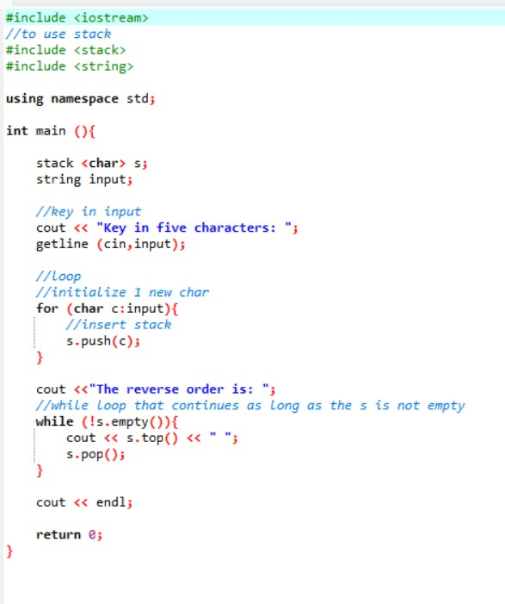

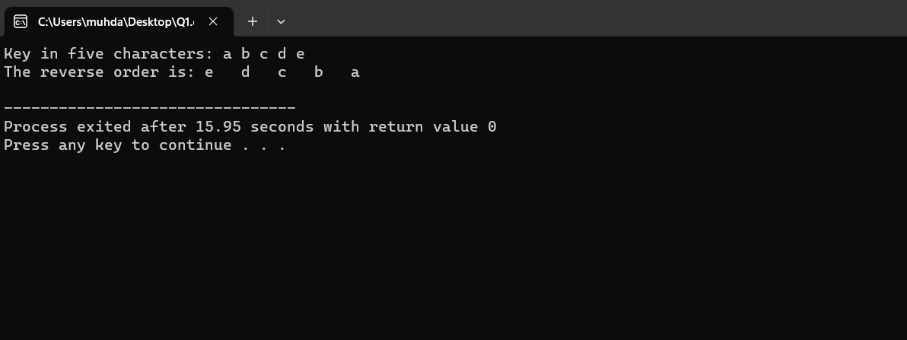

2. Create a program to get 10 numbers from user and count how many odd numbers and even numbers key in by user. (Modify program in Chapter 3 on Stack)

Sample output :

Key in 10 numbers : 10 2 4 5 7 3 5 9 1 8
Numbers entered are : 8 1 9 5 3 7 5 4 2 10
There are 4 even numbers and 6 odd numbers.

ANS:

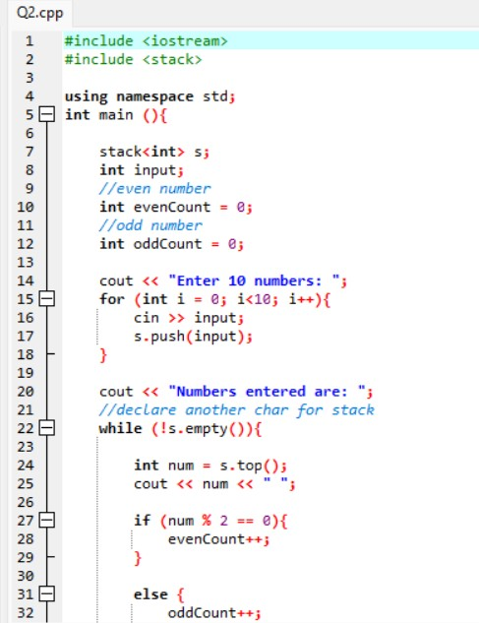
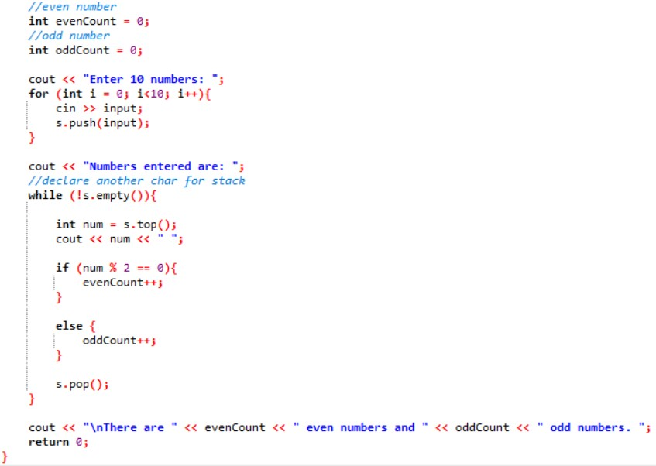

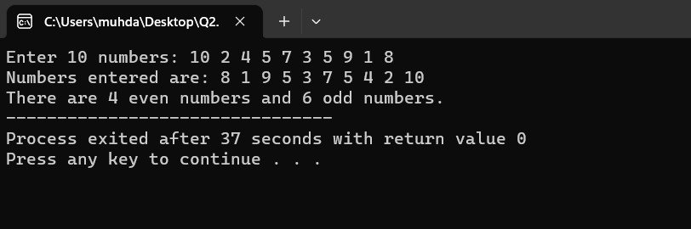
3. Convert the following infix expression to postfix expression.
- a+(b*c+d)/e
- (b*b-4*a*c)/(2*a)

Infix | Postfix
a+(b*c+d)/e | abc*d+e/+
(b*b-4*a*c)/(2*a) | bb*4a*c*-2a*/

4. Evaluate the following postfix notation.

- 4 5 7 2 + - *

(Tip : Bottom – Top)
+ | - | *
2
7 | 9
5 | 5 | -4
4 | 4 | 4 | 16

4 * - 4 = -16

- 3 4 + 2 * 7 /

₊ | * | /
4 | 2 | 7
3 | 7 | 14 | 2

14 / 7 = 2

- 5 7 + 6 2 - *

₊ | - | *
 | 2
7 | 6 | 4
5 | 12 | 12 | 48

12 * 4 = 48

- 4 2 3 5 1 - + * *

- | + | * | *
1
5 | 4
3 | 3 | 7
2 | 2 | 2 | 14
4 | 4 | 4 | 4 | 56

14 * 4 = 56

- 4 2 + 3 5 1 - * +

+ | - | * | +
 | 1
 | 5 | 4
2 | 3 | 3 | 12
4 | 6 | 6 | 6 | 18

12 + 6 = 18
Submission question

Given to you an empty stack, A of an array B [5], and two integers a and b. Draw a sequence diagrams of A, a and b after each of the following operations:
b
a
A
4
3

[4]
[3]
[2]
[1]
[0]

- A.push (a*b);
Given A = 4
Given B = 3
[4]
[3]
[2]
[1] | B
[0] | A | A*B | 12

- cout<< A.pop ( );
[4]
[3]
[2]
[1]
[0]

Output = 12

- A.push (a+b);

[4]
[3]
[2]
[1] | B
[0] | A | A+B | 7

- A.push(b-a);

[4]
[3]
[2] | A
[1] | B
[0] | 7 | B-A | -1

Updated:

[4]
[3]
[2]
[1] | -1
[0] | 7

- a=A.pop( ) / 2;

[4]
[3]
[2]
[1] | -1 | -1/2 = 0
[0] | 7 | 7

Updated

[4]
[3]
[2]
[1]
[0] | 7

Value of A is now : 0

- A.push(10);

[4]
[3]
[2]
[1] | 10
[0] | 7

Updated

[4]
[3]
[2]
[1] | 10
[0] | 7

vii. if (A.pop( ) > 5)
A.push(b);

From Question (iv)
[4]
[3]
[2]
[1] | 10
[0] | 7

TOS = 10
Since 10 > 5
Thus push (b)
b value = 3

Thus…

[4]
[3]
[2]
[1] | 3
[0] | 7

